

Summer Newsletter

W

elcome to this issue of our Practice Newsletter. The newsletter is to provide patients with any news, information or forthcoming events. If you have any suggestions as to what you would like to see in your newsletter, please inform a member of staff.

## Staff Training Days

Please make a note of the dates below when the surgery will close.

 Wednesday 18th June

 Wednesday 16th July

Wednesday 13th August

We will close at 12noon on the day of training and re-open the following day at 8.00am. If you need a Doctor in an emergency, please telephone NHS111.

## Missed Appointments

During the months of March, April and May a total of 741 patients failed to attend their appointment. Please telephone the surgery if you are unable to attend your appointment then the appointment can be used for someone else who needs it.

Yoga4health Sessions

We will be offering yoga sessions for patients starting September, there is limited places so please contact the surgery if you are interested.

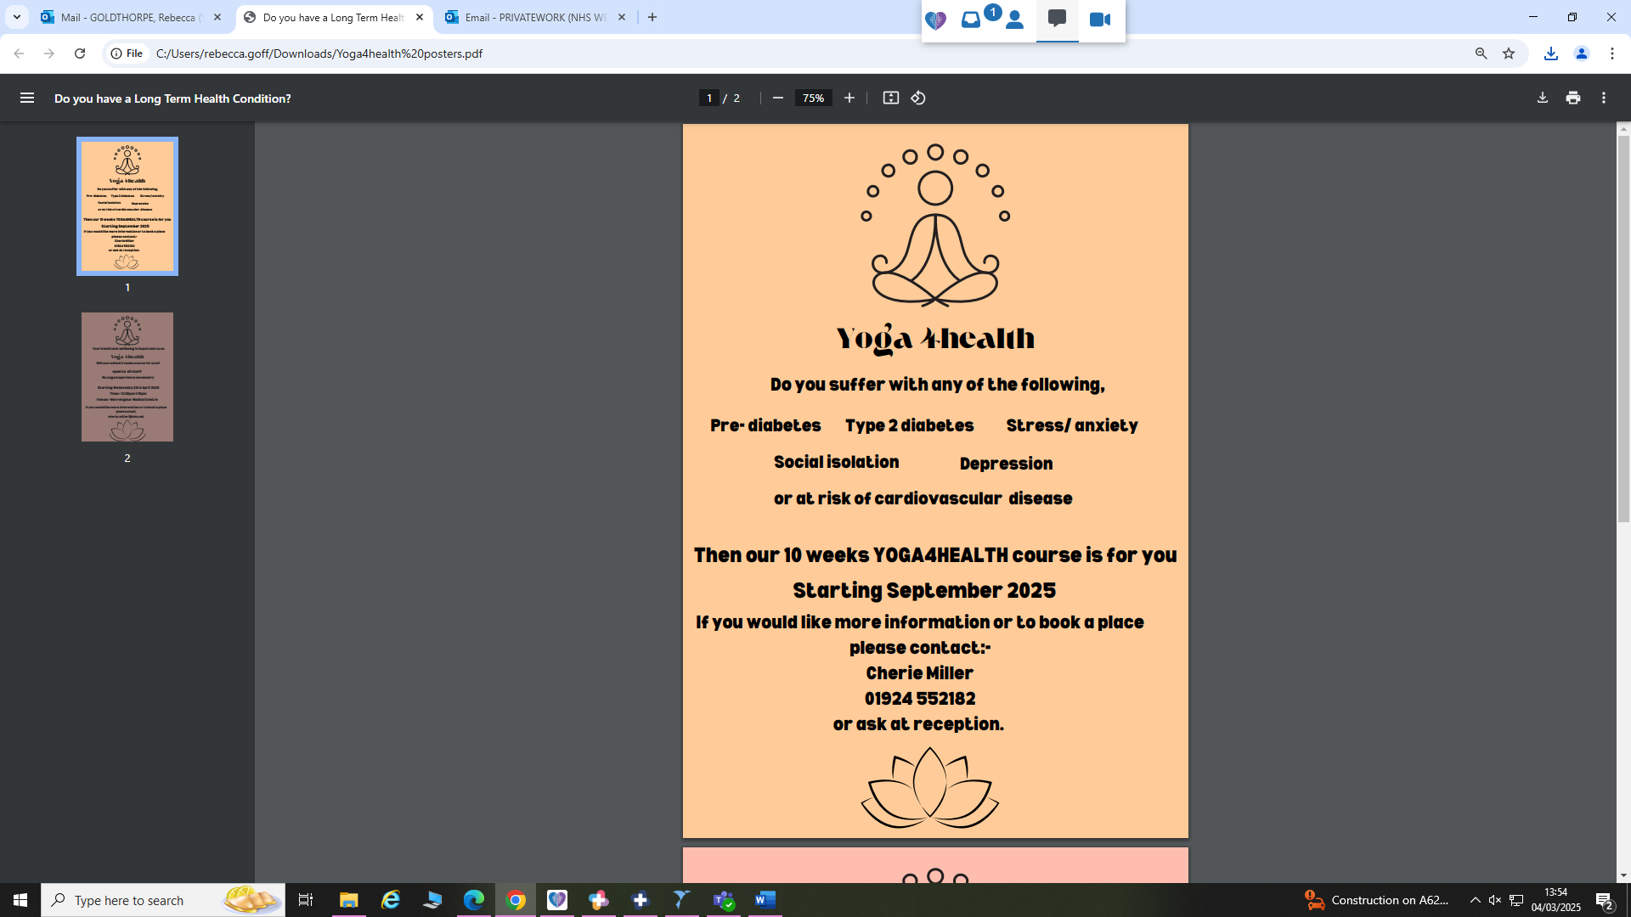

Proud to be a parkrun practice

For those who may not be familiar, parkrun is a health and wellbeing charity which delivers weekly parkrun events on Saturday mornings., our local park being Thornes Park.

Park run is:

 ● Free to take part in!

● Organised by local volunteer teams

● Social, welcoming, fun and friendly

● Open to people of all ages, backgrounds and abilities - participants can walk, jog, run, volunteer or spectate

Armed Forces veteran friendly accredited GP practice

## We are an Armed Forces veteran friendly accredited GP practice. This means that, as part of the health commitments of the Armed Forces Convenant, we have a dedicated clinician who has a specialist knowledge of military related health conditions and veteran specific health services. This is important in helping individuals who have served in the Armed Forces get the care and treatment that is right for them.

**If you have served in the UK Armed Forces, please let your health professional know to ensure you are getting the best possible care.**

The Aims of the Patient Participation Group

We have a well-established Patient Participation Group (PPG) and are hoping to recruit new members to ensure the whole patient community is represented. The PPG should act as the voice of the patients, reflecting local views and having a say in major changes and decisions taken within the Practice. At the Practice we use the PPG as a sounding board for new ideas we may wish to try.

If you would like to join our group, please contact Nicky for more information.

Staff News

We would like welcome and introduce Lucy our newest staff member who has joined our Care Navigation / Administrative team.

Holiday Vaccinations

If you are intending to go abroad, it is best to check what vaccinations you may require. You should make a separate appointment for each family member with the Practice Nurse allowing at least four to six weeks before travel to discuss and arrange any vaccinations and travel advice.

Should you require any vaccinations which are not available on the NHS please note that the Practice no longer administers private travel vaccinations. The Nurse will however be able to advise however where you can access these elsewhere. The cost of travel vaccines at private travel clinics / pharmacies will vary, but it could be around £50 for each dose of a vaccine. It is therefore worth considering this when budgeting for your trip.

Your local pharmacy can also assist you if you require anti malaria tablets.

Don't leave getting your travel vaccination advice / vaccinations done to the last minute as we may not have appointments available at short notice and leaving them to the last minute can also affect how effective they are in protecting you!

## GP Care pessary appointments

GP Care are offering pessary appointments, if you are interested in one of these appointments please contact the surgery.

## Autumn Newsletter

The Autumn Newsletter will be issued in September 2025

Please let us know if there is any information you would find useful or if you would like to know more about our services.